**Institute of Technology Tralee**

**BSc. in Computing with Specialism (Group 3) - Year 1**

**Continuous Assessment #2**

**Date: 4/12/13**

**Time: 10a.m. – 12 p.m.**

**Introduction to Programming**

**Instructions:** Attempt the following question. You should use the JCreator IDE for coding. When you are finished you must print out your code for correction.

**________________________________________________________**

**Q1.**

Each Irish citizen is allocated a PPS number once they reach the age of 18 that is unique to them and used for taxation purposes. A valid PPS number will have exactly 8 or 9 characters in total. It will begin with exactly 7 digits and end with one or two uppercase letters. So, for example, 1234567A would be considered a valid PPS number, as would 7863456RT, but 6478TY*%& and 8768086b would both be considered invalid PPS numbers.

You must write a Java program that reads in a user-supplied string and tests it to see whether or not it is a valid PPS number. If it is not, then your program should issue an appropriate message indicating why it failed the test. When dealing with the validation of the **digits section** of the PPS number, you should use a **while loop** – marks will be lost if you don’t use one in this part of the validation routine.

Using the test values as indicated in the screen shots below, the program should give you **exactly** the following output when it runs, including any banners, blank lines, tabs etc.

Also note that there will be a few marks awarded for having a **single-line comment** and **a meaningful multi-line comment at the top of the program**.

**Sample Screen Shots**

**Run 1 – The value entered fails because it doesn’t contain 8 or 9 characters**

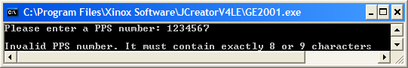

**Run 2 – the value entered fails because one of the first 7 characters is not a digit**

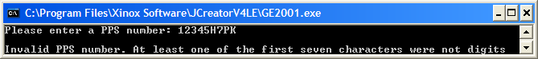

**Run 3 – the value entered fails because the last character is not an uppercase letter (8 characters)**

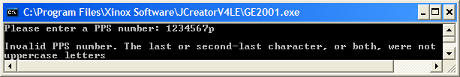

**Run 4 – the value entered fails because the last character is not an uppercase letter (9 characters)**

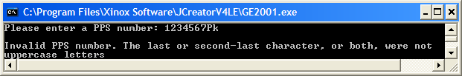

**Run 5 – the value entered is a valid PPS number (9 characters in length)**

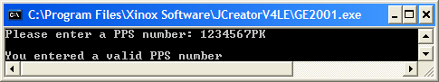

**Run 6 – the value entered is a valid PPS number (8 characters in length)**

